**Ball Game Documentation**

**B00107064 – Group 5 – Leonardo Maurins**

Game concept: 3rd Person ball overview player.

Player’s incentive to complete: Collect all diamonds and return to the finish point.

UI Objects: Main Menu, Instructions menu (Explaining how to play), You lost (restart menu), You won; continue etc (Win menu), Final menu (You won, play again?)

Collision: Colliding off potential walls/objects/collecting Diamonds.

Animation: Diamonds rotating/Player ball rotating if counts/Floating projectiles.

Instantiation: Flying hazardous projectiles(prefabs).

Audio: Background track, menu sounds, ball rolling sound, 3D sound of projectiles, collecting Diamonds.

Scenes: Welcome/Start game, Levels 1-2/4 scenes, Level won(continue), Level Lost(Retry), Game complete (Play again?)

Unique Selling Point: The player ball and it’s functions.

**Project Requirements**

* + Game play design
    - Is it appropriate for your target age group? (Age groups 5-8)
    - What are the incentives (Diamonds remaining)
    - Goals (Collecting all Diamonds/Progressing to the next level)
    - Is it interesting/fun (Depends on your definition of fun and age)
    - Is it too hard, too easy? (Progressively harder as required)
  + Level design
    - Can the user navigate appropriately? (Yes)
    - Are the chosen assets suitable for the game? (Personal preference but yes)
  + HUD design
    - How will the HUD look? (Diamonds remaining top left and hearts display lives remaining top right via heart icons)
  + Interactions
    - All interactions should be well considered (Collision/Trigger events that run events based on collision/trigger with the player ball)
    - Be sure to offer examples of all event based programming that we covered in the labs.
      * Events can turn on a light or sound, change a value in the HUD, play an animation, trigger another script etc… (Sound of Diamonds collected, score changed in HUD, animation of player/Diamonds/projectiles, triggering scripts from collision)
      * Be sure to include as many examples as possible.
      * Most interactions will trigger multiple events.
  + Audio design
    - Audio is extremely important to the ambience of a game and is straightforward to implement.
    - Consider what sounds you would like to play for each interaction. (Background music, collect, menu etc…)
    - Audio can be sourced online for free. Simple google ‘sound effects’.

**Asset Sources**

Name of Asset(s):

1. Handpainted SimplyPack
2. Menu background song
3. Item pickup sound
4. Ball Material
5. Simple Gems
6. Collect Sound
7. Chargen Font
8. Explosion Sound
9. Damage Sound
10. Finish platform checkered texture
11. Game background song
12. Menu Sound selection
13. Rolling ball sound and skybox images

Origin of asset(s):

1. <https://assetstore.unity.com/packages/2d/textures-materials/handpainted-simplypack-122893>
2. <https://freesound.org/people/yummie/sounds/410574/>
3. <https://freesound.org/people/TreasureSounds/sounds/332629/>
4. <https://www.123rf.com/photo_6111663_seamless-texture-of-bright-random-colored-shapes.html>
5. <https://assetstore.unity.com/packages/3d/props/simple-gems-ultimate-animated-customizable-pack-73764>
6. <https://freesound.org/people/Sirkoto51/sounds/346265/>
7. <https://www.1001fonts.com/6809-chargen-font.html>
8. <https://freesound.org/people/cydon/sounds/268557/>
9. <https://freesound.org/people/InspectorJ/sounds/448226/>
10. <https://pixabay.com/en/chess-board-pattern-chess-black-1520707/>
11. <https://freesound.org/people/Sunsai/sounds/415804/>
12. <https://freesound.org/people/plasterbrain/sounds/243020/>
13. <https://marbleblast.com/index.php/downloads/mbg>

**Code Sources**

**(Anything with an asterisk in comment was assisted by these)**

Script assisted on:

1. Ball Controller
2. Camera Controller
3. Menu Interface
4. Physics of ball (Changed gravity and had issue with ball colliding between platforms, changed default contact offset)
5. The Instructions Interface

From:

1. <https://docs.unity3d.com/ScriptReference/Input.html> <https://stackoverflow.com/questions/41249901/rolling-ball-game-when-i-use-sbackward-ball-fly>  
   <https://answers.unity.com/questions/272202/how-to-make-dynamic-sounds-for-rolling-ball.html>  
   <https://answers.unity.com/questions/598264/counting-gameobjects-with-tag-int.html>
2. <https://answers.unity.com/questions/698254/how-do-i-rotate-the-camera-around-the-player-chara.html>
3. <https://docs.unity3d.com/ScriptReference/Application.Quit.html>
4. <https://answers.unity.com/questions/568974/sphere-collider-catching-edges-of-aligned-cubes.html>
5. <https://www.youtube.com/watch?v=oDBVRcHhc0M> Unity UI Tutorial - Scroll Rect / Scroll View in 60 Seconds”

**Remaining Write Up**

Well to start things off, I got my inspiration from a classic game I enjoyed thoroughly in my childhood called:

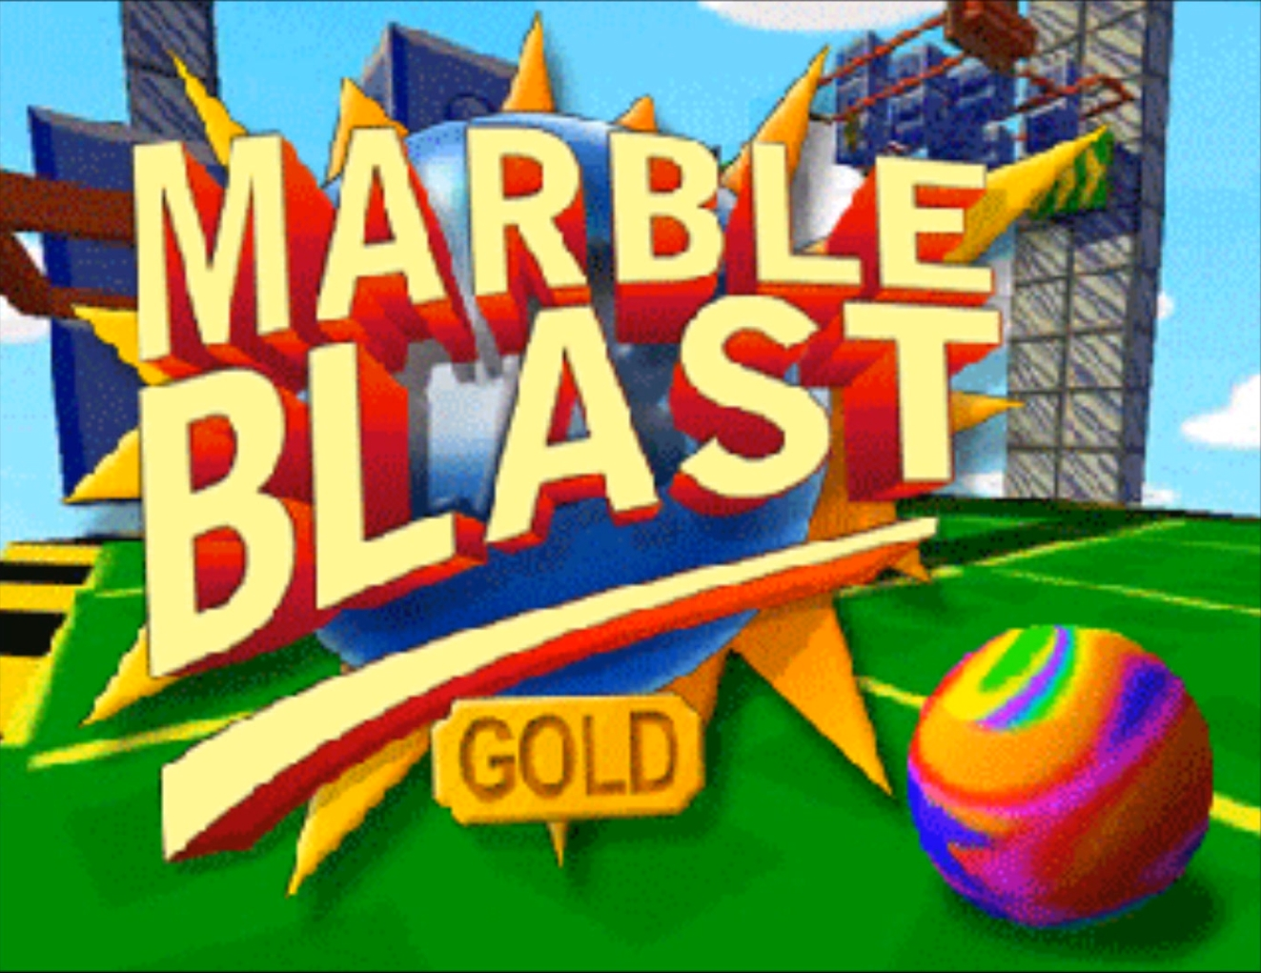

A simple yet effective and repetitive game with a ball for a controller, orbs to collect before reaching the finishing platform and progressing etc.

I have had no intentions of replicating it, was simply an idea for how I could demonstrate my skills with unity and what I’ve learned so far this semester.

Most of my script will already have an immense amount of commenting beside it explaining its purpose and function so there shouldn’t be much I would need to repeat here but nevertheless here it is.

Starting off things simply and casual, I created a simple platform for where I could design my ball that I would control and the camera that would follow it while constantly updating to it’s prior set location apart via the CameraController script.

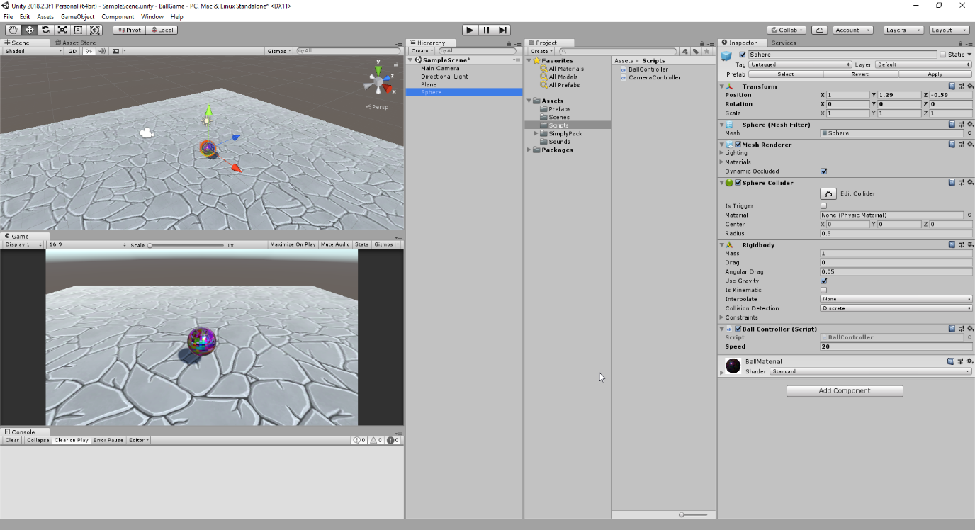

As for the ball movement and control, I had used InputAxis to obtain the users input using WASD keys to control the ball, with the ability to also change the speed at which it travelled.

Most of the Input Axis code was assisted from <https://docs.unity3d.com/ScriptReference/Input.html>

As for the camera controls

<https://stackoverflow.com/questions/41249901/rolling-ball-game-when-i-use-sbackward-ball-fly>

which also helped with a problem I had for the ball flying upwards when I was traveling backwards.

As you can also see I’ve obtained some graphical materials from the asset store and google images for my ball from the following sources:  
<https://assetstore.unity.com/packages/2d/textures-materials/handpainted-simplypack-122893>

<https://www.123rf.com/photo_6111663_seamless-texture-of-bright-random-colored-shapes.html>

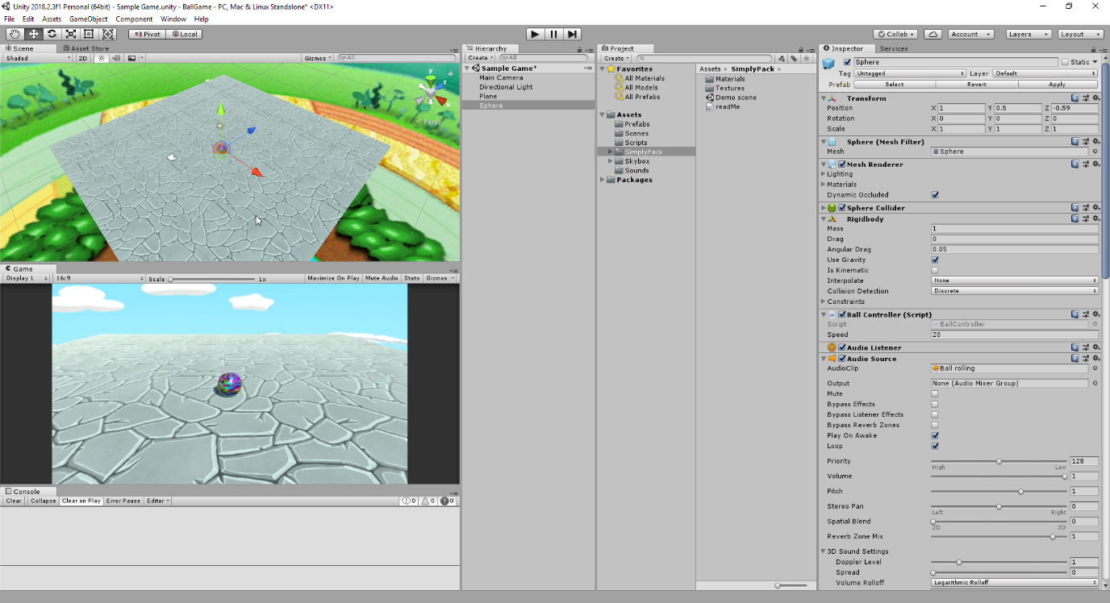

By the next stage I have managed to make my ball play a sound when rolling around the y axis between 0.5f and 1f which was later changed to searching for a ground tax on OnCollisionStay for efficient use of colliding with any ground objects. The ball sound increased depending on how fast you were going making it seem synced realistically with how you’d expect it to sound if you were moving faster. The following script helped me achieve such with advice

<https://answers.unity.com/questions/272202/how-to-make-dynamic-sounds-for-rolling-ball.html>

As you can also see there was also a skybox background by this point which I have already fiddled around before with for knowledge and figured out with general unity functions, Material > Shader > Skybox and adding images according to the location. The images I admittedly obtained from the game I was inspired from files as I wasn’t content with what the unity store had to offer, for free anyway.

Also by this point I had figured out how to make the ball jump using AddForce with the spacebar key and attaching a jumpsound to that but the rather most difficult part of the ball was adding the camerarotation around the ball using arrow keys which I gained some support from the following source for:

<https://answers.unity.com/questions/698254/how-do-i-rotate-the-camera-around-the-player-chara.html>

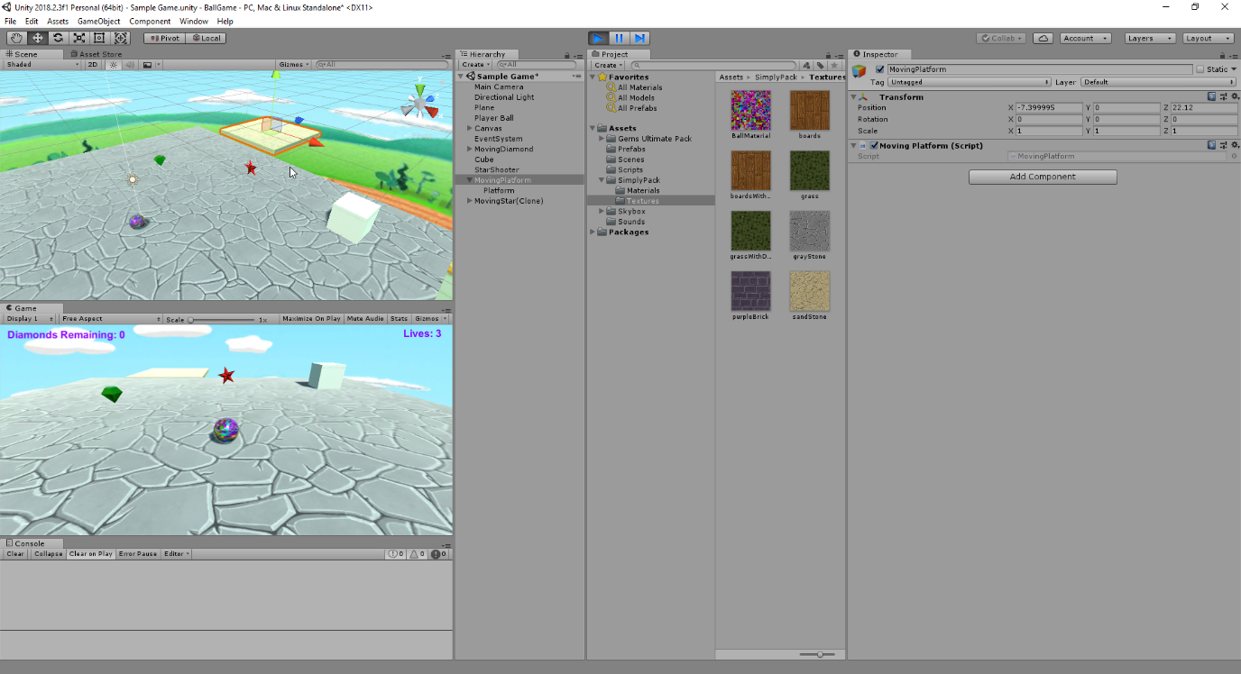

By this stage which was quite a bit further in(Unfortunately I get too carried away with being so into developing that I forget to take more progress pictures), I have imported another asset for more materials and prefabs of premade 3D objects to use in my game such as diamonds and stars from:

<https://assetstore.unity.com/packages/3d/props/simple-gems-ultimate-animated-customizable-pack-73764>

For the diamonds I had created a transform.Rotate script to turn them initially until we learned about animation at a later stage, I had them also on trigger with the ball to be destroyed if touched and remove a count from the canvas for the amount remaining.

For the platform in the back I had the simple back and forth if statement testing so its bouncing back and forward for later purposes.

The red stars would do the same but instead reduce from your lives counter which I had later changed to heart icons to represent health. In this picture here I was testing an instantiate function of the ball being shot out of the box and moving in a direction while rotating and then being destroyed after a timer. Again later improved to randomly spawn in different locations at different speeds.

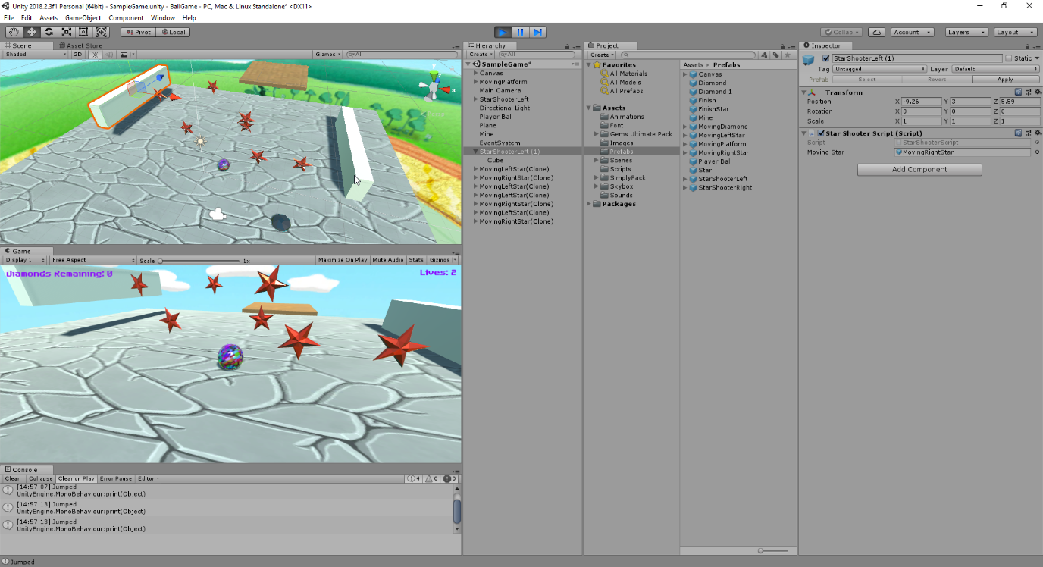

As such spawning between random locations along that wall and invoking a new random spawn time each time within itself which can be seen in more detail in the StarShooterScript.

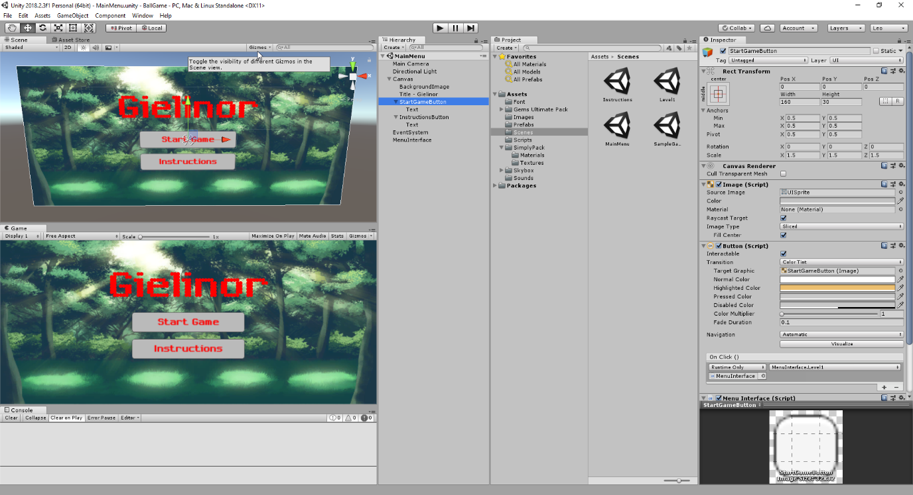

Along with my star lives count it was about time to add a menu interface for when that count actually reached zero which I simply had it do with an if statement and SceneManager.LoadScene. Above is simply the main menu but shows an example of how my menu interface looked at the start and the MenuInterface gameobject the button had which contained my MenuInterfaceScripts for anything dealing with menus loading etc.

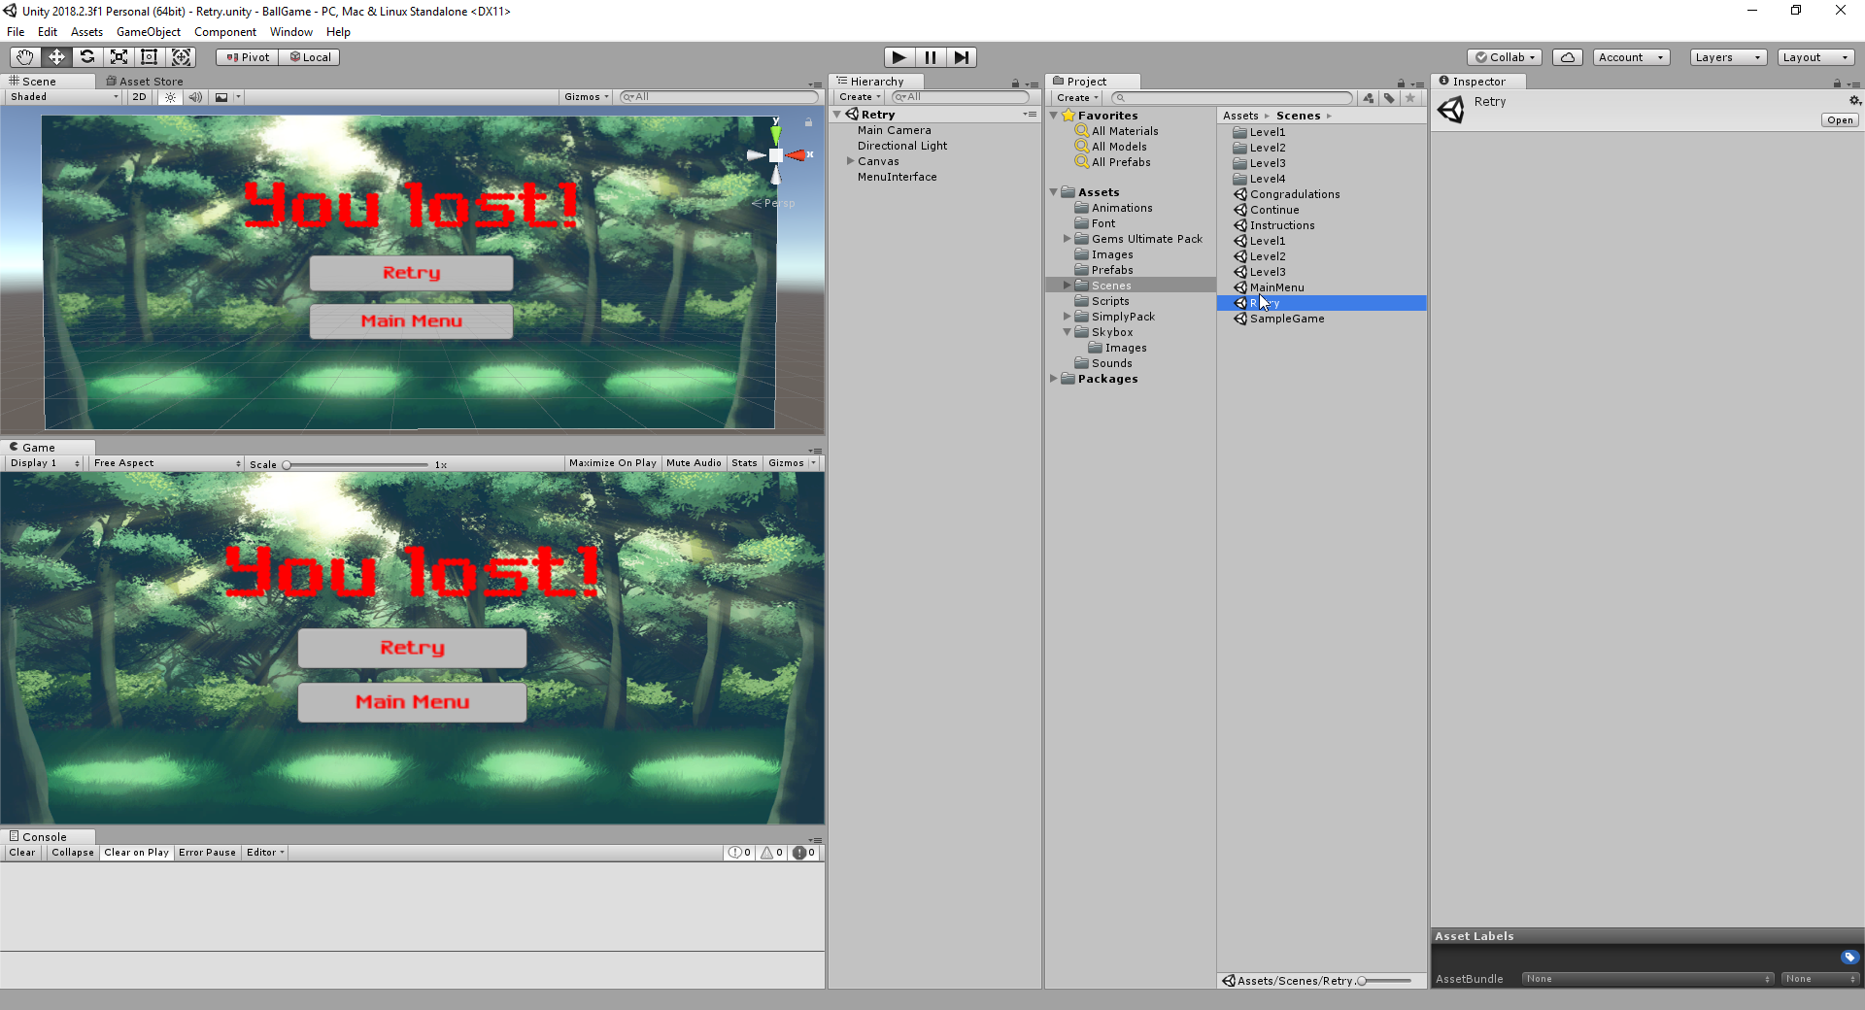

This would have been the lose screen you’d see if you lost all your lives or if you fell off the map and your wall went below -50 on the y coordinate.

Which another interesting feature I added to was the camera’s position freezing in place and instead directly following the ball with Transform.LookAt(player.transform) for a unique effect with a text popup “Out of bounds” at -5 y coordinate for both.

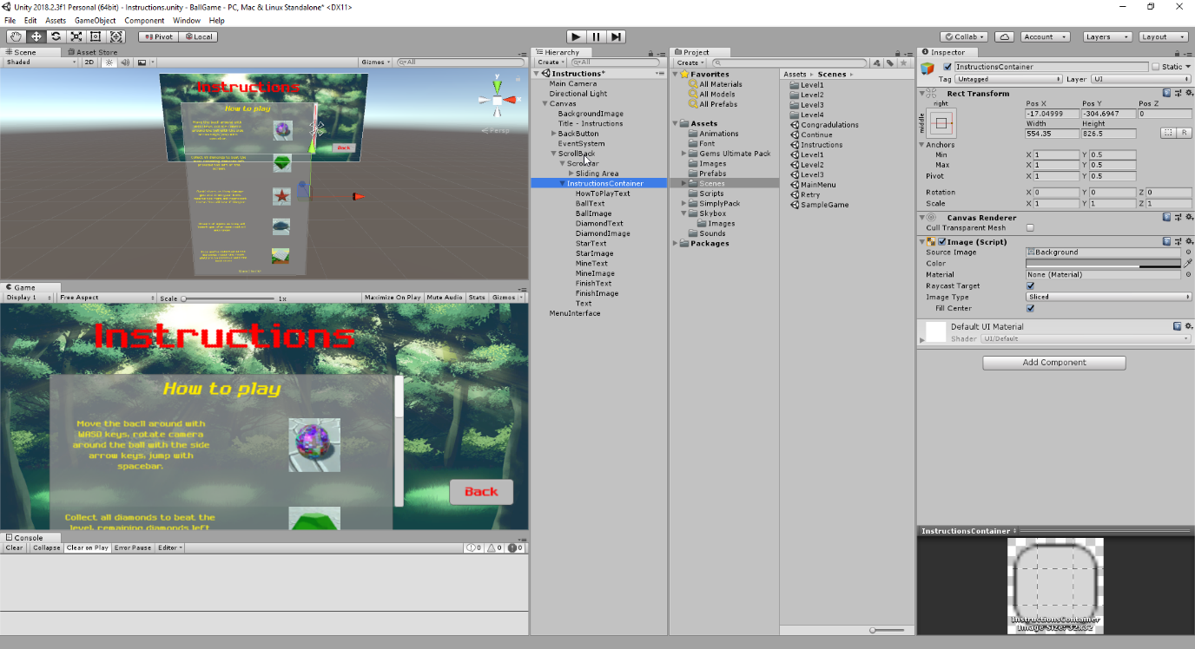

The instructions scene interface which I found rather fascinating and most I could recall but still required some assistance with from a quick “Unity UI Tutorial - Scroll Rect / Scroll View in 60 Seconds” tutorial.

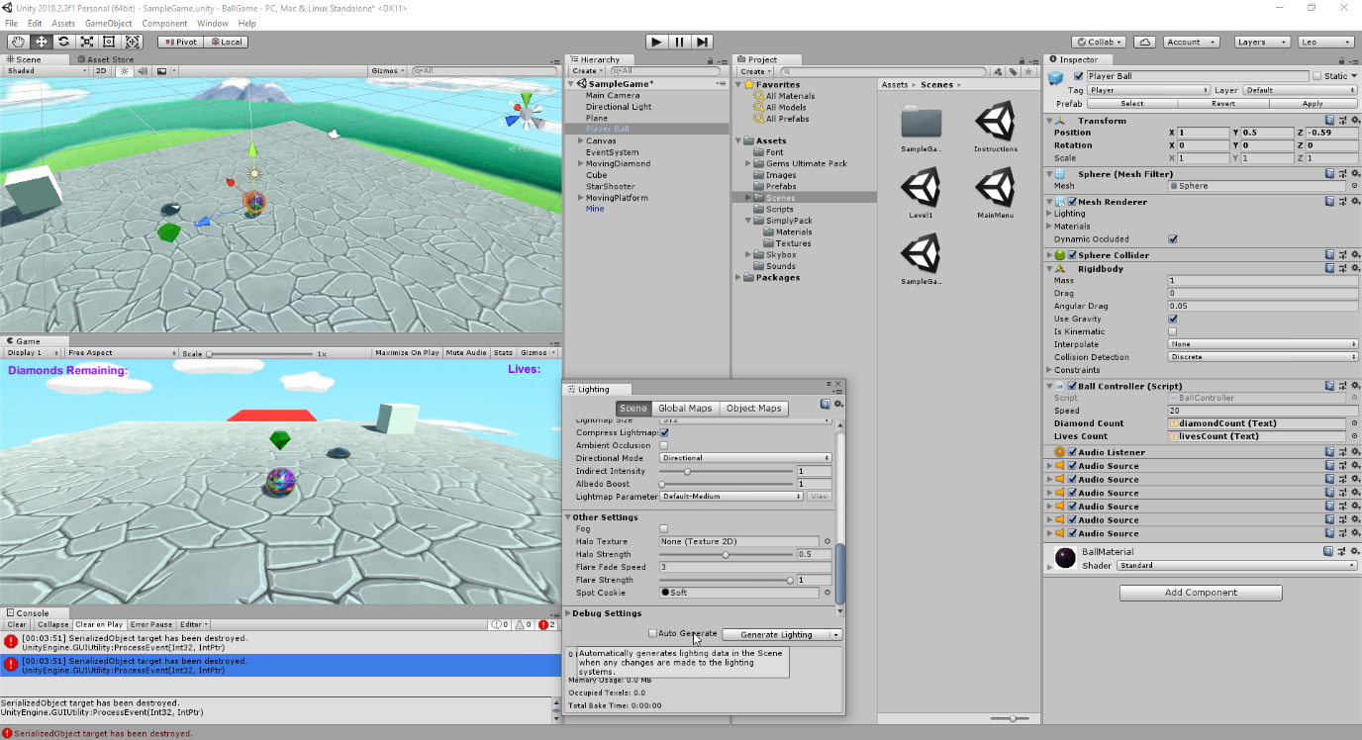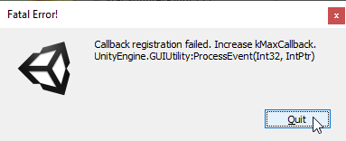

A problem I’ve had quite the joy of running into multiple times while developing my game with sources online pointing to various ways of solving it with the major ones either with building a light source for each scene or deleting the entire library and restarting the game as such to build a fresh one as such which seemed to solve the problem somewhere along the lines.

<https://forum.unity.com/threads/please-help-guys.533402/>

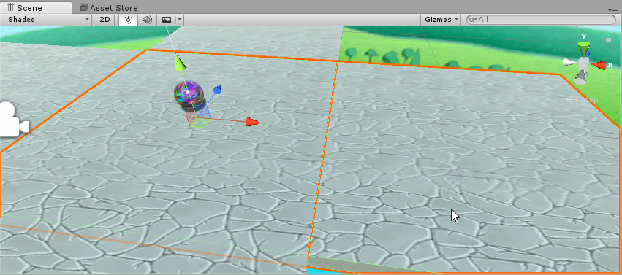

Another problem I had to deal with was my ball colliding with the edges of platforms even though they were uniformly connected and on the same y coordinate. I found my solution in <https://answers.unity.com/questions/568974/sphere-collider-catching-edges-of-aligned-cubes.html>

By turning down the contact offset but also turning the gravity higher to make the ball fall down faster as I had a rather overpowered jumping ball that could travel vast distances with a single jump which was convenient to improve of the game’s quality.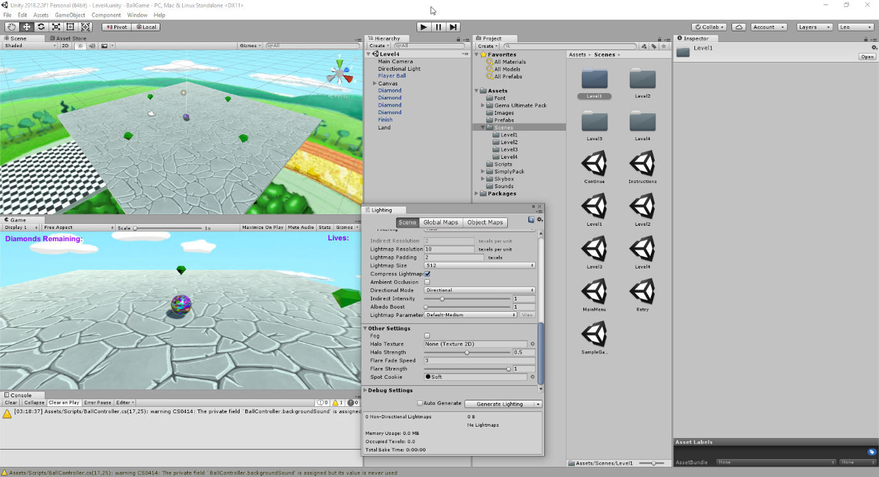

By this point, this’d have been my basic first level start complete with simple diamonds to pick up that would play a sound on triggerEnter with them and get destroyed, most of this script would go into the ball rather than the diamonds themselves because the diamonds sound would only play for such a small amount of time before it actually got deleted and hence stopped the audio source from continuing to play. Once the user had collected all the diamonds, the finishing platform would only then allow them to load into the next scene if entered.

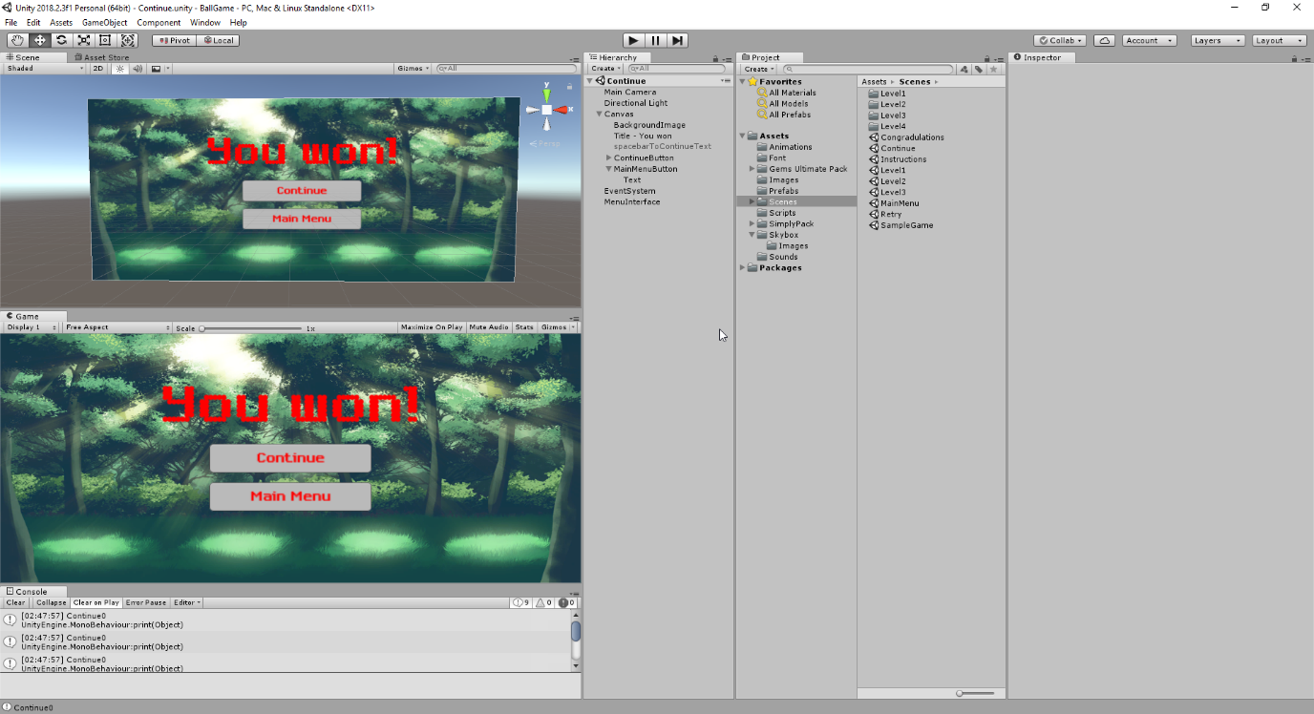

A you won screen with an option to return to the main Menu or continue onto the next level, I used a sceneCount in the MenuInterface script to count the current scene the player should be on and if statements as such with sceneCoutn++, sceneCount=0; to reset if you go to main menu etc.

In the actual menus I was trying to implement sound for a button press but because it was playing the sound on button press but also switching scene, it stopped playing that sound immediately on switch half way through so my solution to this was adding a sound to play on awake when the menu scenes were loaded, on top of already the background music which also looped for general background sound (Same thing I used in game).

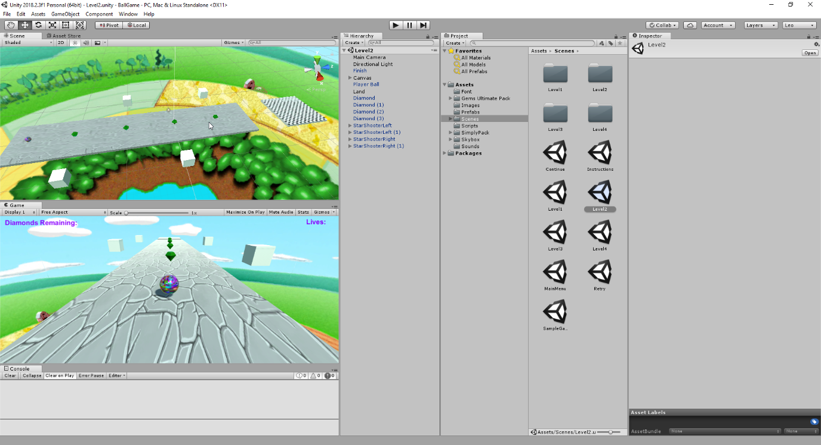

My then 2nd basic level at the time which had stars spawning out of those cubes at random times meanwhile rotating the diamonds in circles for the player to attempt to collect before reaching the final platform.

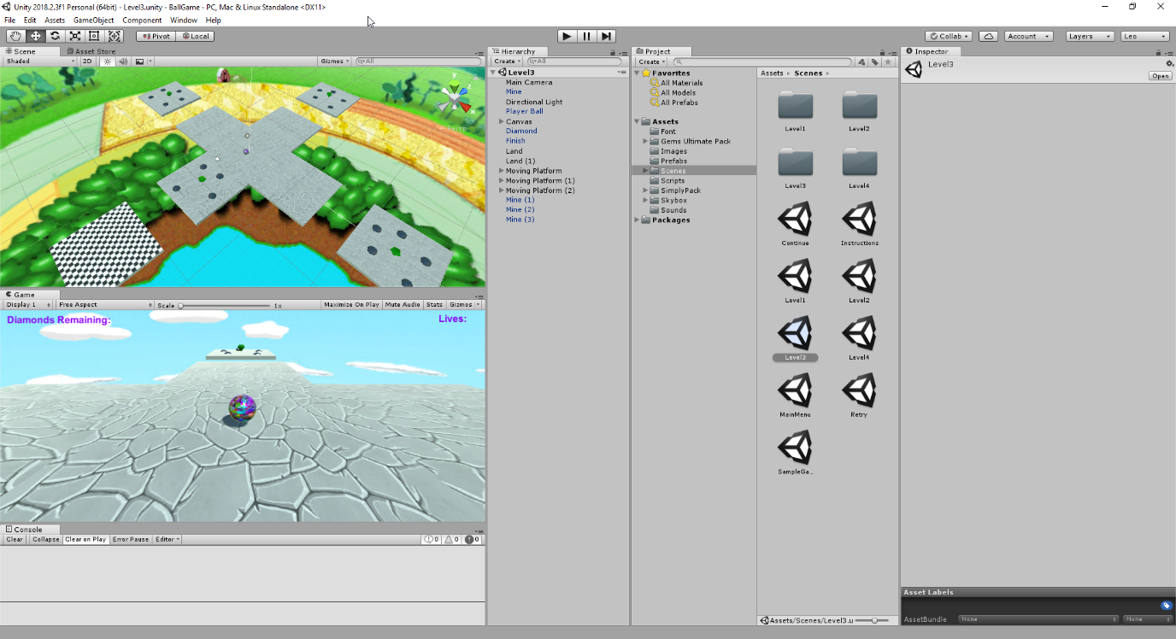

My 3rd and final level of the game, 3 platforms with mines that would AddForce to the player ball upwards and sideways with an explosion sound connected on impact while the platforms moved side to side and the mines/diamonds attached.

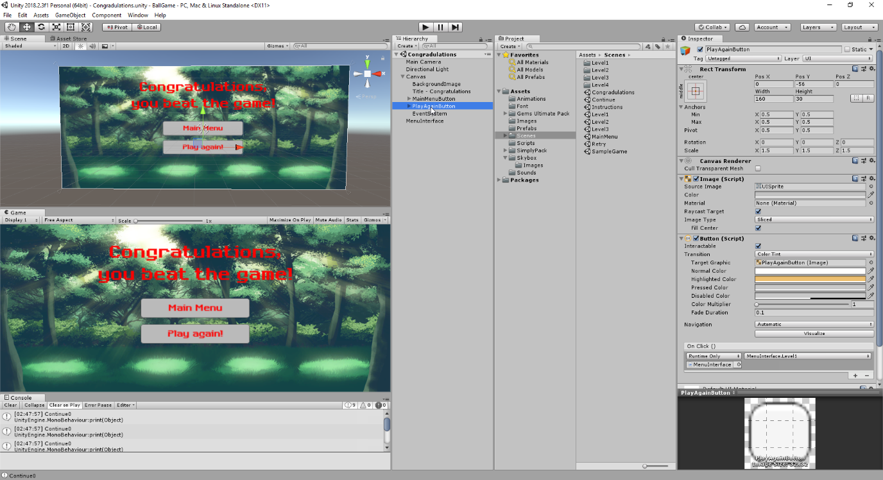

After which the final menu scene would play and congratulate you offering you to return to the main menu or play again from level one.

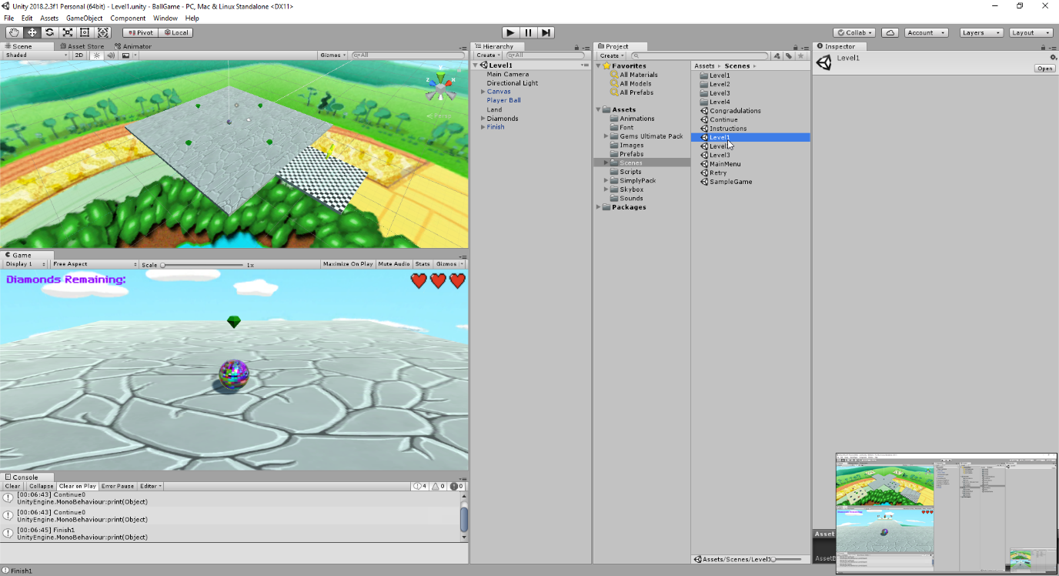

By this stage I was going back over the game and making improvements here and there, the first being changing lives count to RawImages of hearts which I obtained off google and had set as PNG in the canvas, disabled using invoke and such in the Ball Controller script.

I had also added hints to the game for certain events for such as this level when you collected the first diamond it would give you a popup about using arrow keys to rotate the camera.

As well as requested, I had added a star that animated above the finish platform for the player to know where to go when supposedly finished and demonstrated my knowledge of the animation tool (Also have used it on stars in certain places).

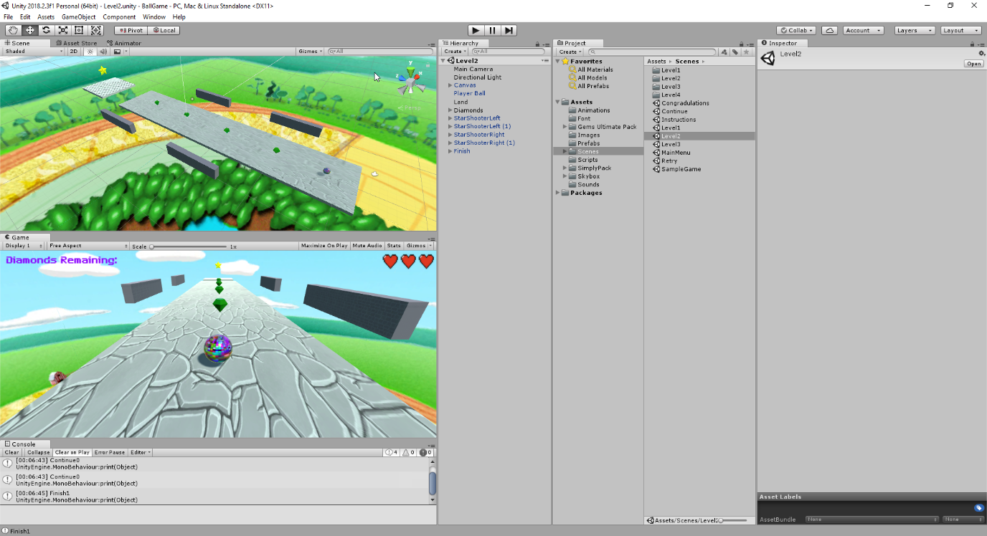

For level 2 I had improved the spawn location of stars varying between those walls randomly along the line and also spawn rate being much more random and changing each time rather than InvokeRepeating only setting a random value from Random.Range once which was a problem. (All the scripting for shooting stars, moving them and such was done by StarShooterScript, MovingStarScript,StarScript etc.) The final diamond on this level would give you a tooltip for jumping with spacebar to be able to reach the final platform.

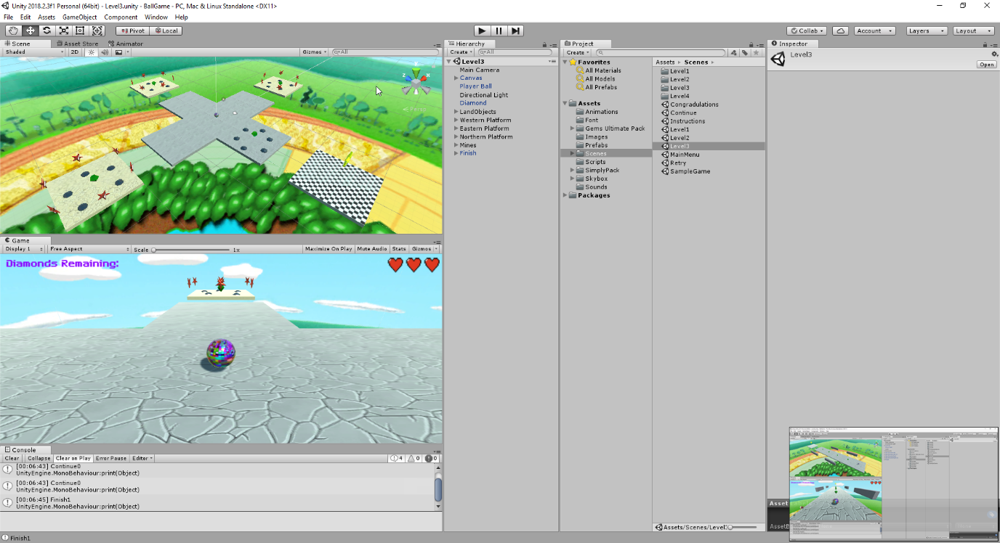

My final level which may have been a bit overkill but I’m proud of it nonetheless and the game is intended to get harder each time right? Heh. Changed texture of platforms, added those same stars that are circling an empty gameobject that’s connected to the center of those platforms (using rotateAround script) meanwhile the platforms move side to side using (xAxisMovement and zAxisMovement) scripts depending on location.

Finally the finish platform also has a FinishScript which runs particular script only after making sure some if statements are true such as all diamonds having been collected, and if the platform is colliding with the player as well as what sceneCount the game is currently on to determine whether to load the continue scene or congratulate scene. Also a hint pops up if the platform enters the platform with not enough diamonds that they should collect the remaining ones. I called the sceneCount from MenuInterface in FinishScript using MenuInterface.sceneCount to obtain the variable.

That pretty much summarises my game, hope you enjoyed it, anymore information should be plentiful filled in the comments of the scripts.

**B00107064 – Group 5 – Leonardo Maurins**